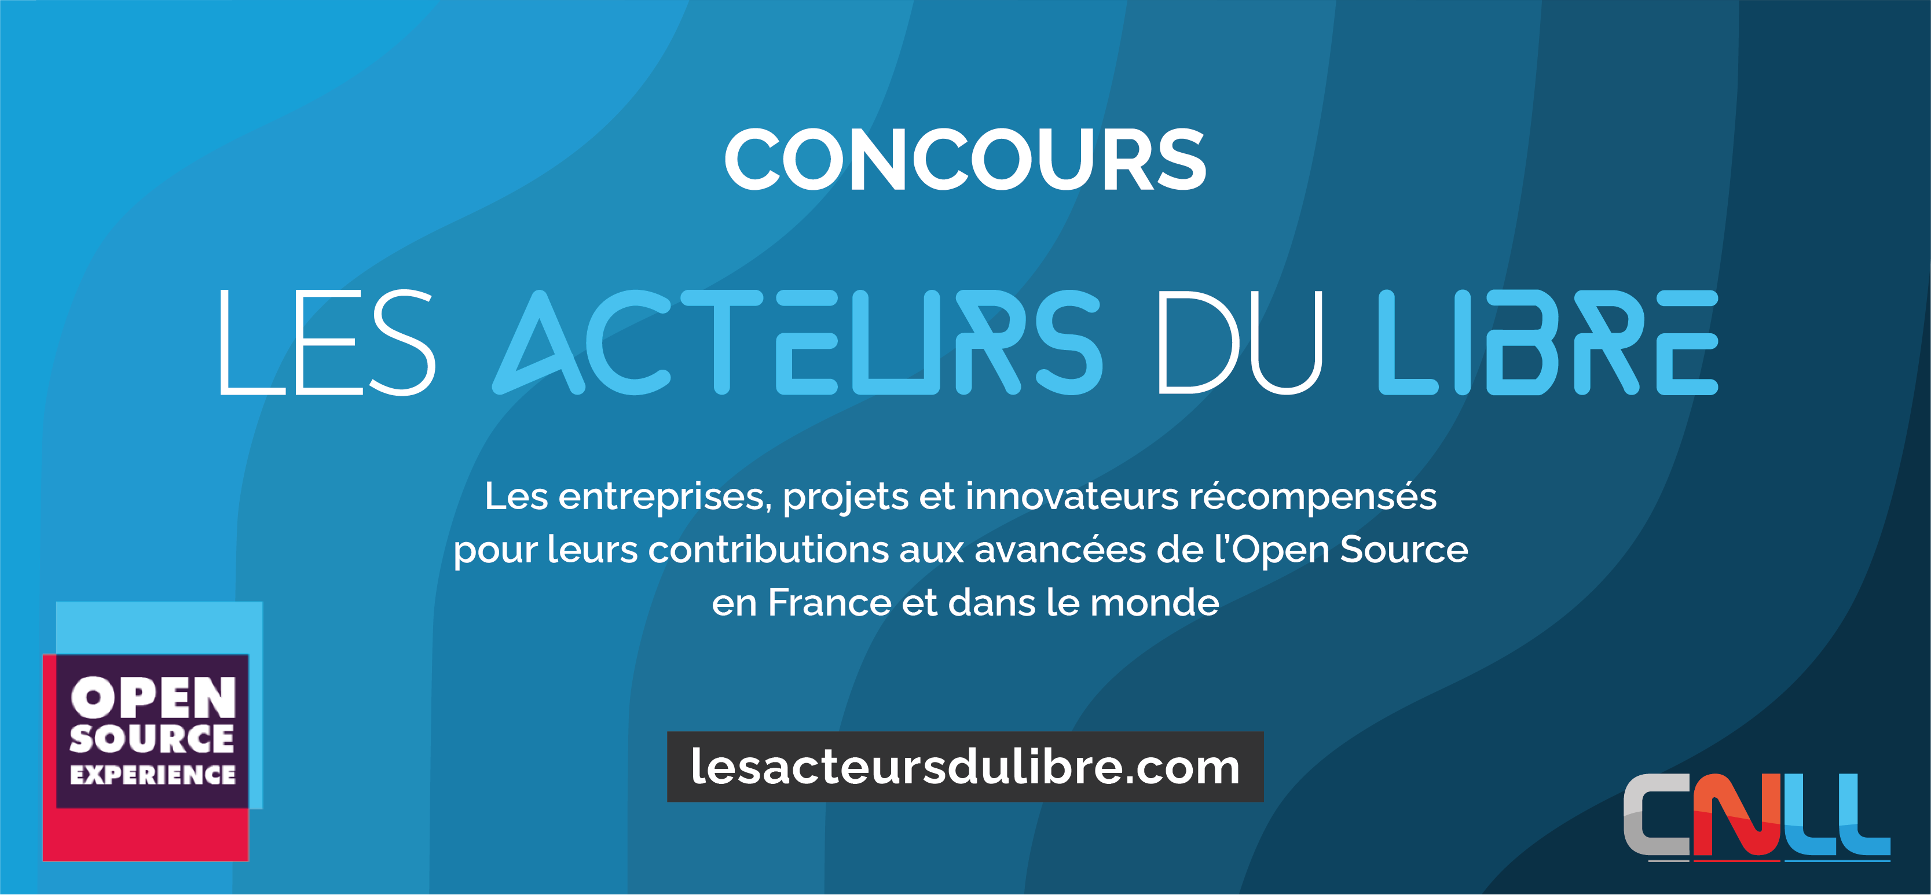

Thank you for pre-registering for the Acteurs du Libre competition!
We thank you in advance for filling out this application form dedicated to the APELL category and returning it no later than Friday October 10 to contact@lesacteursdulibre.com.
Please complete the generic questions 1 to 3 and then fill in the questions specific to the category in which you are entering (Part 4). The sub-questions of Part 4 are not exhaustive, so please feel free to expand on your answers using the areas provided for free comments. As a reminder, only one entry per candidate will be examined. Previous winners are not eligible to enter again.
The awards ceremony will take place during the Open Source Experience on 10-11 December at the City of Sciences in Paris. If you have any questions, please contact us at the same e-mail address.
NOTE: Any organization or project may apply, but its head office must be based in France. Organizations that are not members of the CNLL are accepted. The theme of the competition is software, not hardware. Organizations based outside France and Europe are allowed to apply in the ‘Europe’ category.
For applications from the public sector, only central and devolved administrations may apply (local authorities must apply to the dedicated NLT competition).

Name of company / organization:

Contact name:

Position:

E-mail:

Telephone number:

Category in which you are submitting: (tick the appropriate box):

Business Development Award
Best Strategy Award
Open and Ethical Digital Award
Special Jury Award
European Award in collaboration with APELL | X
Public-private collaboration Award

1. Presentation of company/structure/administration (date established, size, mission, turnover, etc.)

2. Business overview (technologies, business lines, customers, etc.)

3. Detailed presentation of the open-source business (projects, community, commitments, business model, etc.).

4. What do you think justifies your application in the category: European Award in collaboration with APELL
(You will find below the list of questions used by the jury during the assessment. If you are unable to answer certain questions, please specify the reason).

Since this category targets organizations located outside France, the application can be written in English. Please describe in detail the project, the activity, and recent key successes, for instance in France. This price targets companies or organizations that achieved commercial success for an open-source based activity and whose headquarters are in Europe but outside of France.

  - Approximate revenue over the last 3 years (if the organization is older than 3)
  - Export-related revenue, or the percentage of the overall revenue devoted to export
  - Number of employees worldwide
  - Number of employees in Europe
  - Current business model
  - Expected revenue growth this year
  - Expected employees growth this year
  - Funds raised (if applicable)
  - Do you have partner companies? (ISV, VAR, resellers…)
  - Community aspect: number of stars/followers/users of the open-source version, participation to open-source community conferences or events, number of press articles...
  - Free comment

